**Windows Version**

/*

10/1/2017

Nabir Migadde/Melanie Sou

1648223/1606508

CISP 360 - M/W 1:30pm - 2:50pm

Spring 2017

Assignment #6 Math Tutor

Help a student improve on their math skills

*/

#include <iostream>

#include <stdlib.h>

#include <cstdlib>

#include <time.h>

using namespace std;

//Math Tutor

int main() {

//Initialization of Variables

int choice;

double num1;

double num2;

double ans;

double userAns;

//Loop for Tutor

do {

//Seed randomization based off time

srand(time(NULL));

//Set random numbers for calculations

num1 = (rand() % 300) + 1;

num2 = (rand() % 300) + 1;

//Math Tutor Menu

cout << " Math Tutor Menu" << endl;

cout << "-------------------------------" << endl;

cout << "1. Addition problem" << endl;

cout << "2. Subtraction problem" << endl;

cout << "3. Multiplication problem" << endl;

cout << "4. Division problem" << endl;

cout << "5. Quit this program" << endl;

cout << "-------------------------------" << endl;

cout << "Enter your choice (1-5): ";

cin >> choice; // User's choice

//Do action based off User's choice

switch (choice) {

case 1: // Addition

ans = num1 + num2; //Calculations

//Display Calculation to User

cout << " " << endl << endl;

cout << "Number 1 is : " << num1 << endl;

cout << "Number 2 is : " << num2 << endl << endl;

cout << "What is the answer if you ADD them: "; // User answers the problem

cin >> userAns;

cout << " " << endl << endl;

cout << " " << num1 << endl;

cout << " + " << num2 << endl;

cout << " ----" << endl;

cout << " " << ans << endl;

cout << " " << endl << endl << endl;

if (userAns == ans) { // If user is correct

cout << "Congratulations! That's right." << endl << endl;

}

if (userAns != ans) { // If user is incorrect

cout << "Sorry, the correct answer is " << ans << "." << endl << endl;

}

break;

case 2: // Subtraction

ans = num1 - num2; // Calculations

//Display Calculation to User

cout << " " << endl << endl;

cout << "Number 1 is : " << num1 << endl;

cout << "Number 2 is : " << num2 << endl << endl;

cout << "What is the answer if you SUBTRACT them: "; // User answers the problem

cin >> userAns;

cout << " " << endl << endl;

cout << " " << num1 << endl;

cout << " - " << num2 << endl;

cout << " ----" << endl;

cout << " " << ans << endl;

cout << " " << endl << endl << endl;

if (userAns == ans) {

cout << "Congratulations! That's right." << endl << endl; // If user is correct

}

if (userAns != ans) {

cout << "Sorry, the correct answer is " << ans << "." << endl << endl; // If user is incorrect

}

break;

case 3: // Multiplication

ans = num1 * num2; // Calculations

//Display Calculation to User

cout << " " << endl << endl;

cout << "Number 1 is : " << num1 << endl;

cout << "Number 2 is : " << num2 << endl << endl;

cout << "What is the answer if you MULTIPLY them: "; // User answers the problem

cin >> userAns;

cout << " " << endl << endl;

cout << " " << num1 << endl;

cout << " x " << num2 << endl;

cout << " ----" << endl;

cout << " " << ans << endl;

cout << " " << endl << endl << endl;

if (userAns == ans) {

cout << "Congratulations! That's right." << endl << endl; // If user is correct

}

if (userAns != ans) {

cout << "Sorry, the correct answer is " << ans << "." << endl << endl; // If user is incorrect

}

break;

case 4: //Division

ans = num1 / num2;

cout << " " << endl << endl; //Calculations

//Display Calculation to User

cout << "Number 1 is : " << num1 << endl;

cout << "Number 2 is : " << num2 << endl << endl;

cout << "What is the answer if you DIVIDE them: "; // User answers the problem

cin >> userAns;

cout << " " << endl << endl;

cout << " " << num1 << " / " << num2 << " = " << ans << endl;

cout << " " << endl << endl << endl;

if (userAns == ans) {

cout << "Congratulations! That's right." << endl << endl; // If user is correct

}

if (userAns != ans) {

cout << "Sorry, the correct answer is " << ans << "." << endl << endl; // If user is incorrect

}

break;

case 5: // Exit the program

cout << " " << endl << endl;

break;

default: // Invalid Entry

cout << "The valid choices are 1, 2, 3, 4, and 5. Please choose: 5 ";

cout << "Thank you for using Math Tutor." << endl << endl;

break;

}

} while (choice != 5);

system("pause");

return 0;

}

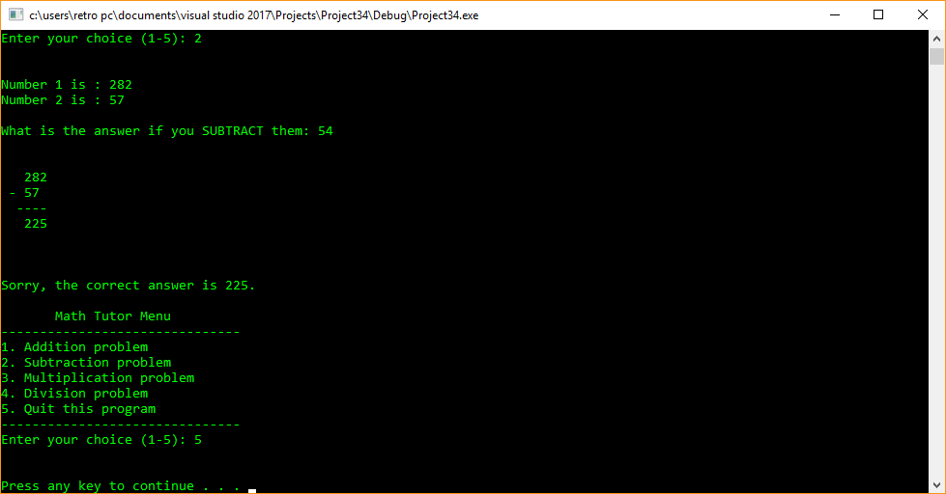

**Linux Version**

/*

10/1/2017

Nabir Migadde/Melanie Sou

1648223/1606508

CISP 360 - M/W 1:30pm - 2:50pm

Spring 2017

Assignment #6 Math Tutor

Help a student improve on their math skills

*/

#include <iostream>

#include <stdlib.h>

#include <cstdlib>

#include <time.h>

using namespace std;

//Math Tutor

int main() {

//Initialization of Variables

int choice;

double num1;

double num2;

double ans;

double userAns;

//Loop for Tutor

do {

//Seed randomization based off time

srand(time(NULL));

//Set random numbers for calculations

num1 = (rand() % 300) + 1;

num2 = (rand() % 300) + 1;

//Math Tutor Menu

cout << " Math Tutor Menu" << endl;

cout << "-------------------------------" << endl;

cout << "1. Addition problem" << endl;

cout << "2. Subtraction problem" << endl;

cout << "3. Multiplication problem" << endl;

cout << "4. Division problem" << endl;

cout << "5. Quit this program" << endl;

cout << "-------------------------------" << endl;

cout << "Enter your choice (1-5): ";

cin >> choice; // User's choice

//Do action based off User's choice

switch (choice) {

case 1: // Addition

ans = num1 + num2; //Calculations

//Display Calculation to User

cout << " " << endl << endl;

cout << "Number 1 is : " << num1 << endl;

cout << "Number 2 is : " << num2 << endl << endl;

cout << "What is the answer if you ADD them: "; // User answers the problem

cin >> userAns;

cout << " " << endl << endl;

cout << " " << num1 << endl;

cout << " + " << num2 << endl;

cout << " ----" << endl;

cout << " " << ans << endl;

cout << " " << endl << endl << endl;

if (userAns == ans) { // If user is correct

cout << "Congratulations! That's right." << endl << endl;

}

if (userAns != ans) { // If user is incorrect

cout << "Sorry, the correct answer is " << ans << "." << endl << endl;

}

break;

case 2: // Subtraction

ans = num1 - num2; // Calculations

//Display Calculation to User

cout << " " << endl << endl;

cout << "Number 1 is : " << num1 << endl;

cout << "Number 2 is : " << num2 << endl << endl;

cout << "What is the answer if you SUBTRACT them: "; // User answers the problem

cin >> userAns;

cout << " " << endl << endl;

cout << " " << num1 << endl;

cout << " - " << num2 << endl;

cout << " ----" << endl;

cout << " " << ans << endl;

cout << " " << endl << endl << endl;

if (userAns == ans) {

cout << "Congratulations! That's right." << endl << endl; // If user is correct

}

if (userAns != ans) {

cout << "Sorry, the correct answer is " << ans << "." << endl << endl; // If user is incorrect

}

break;

case 3: // Multiplication

ans = num1 * num2; // Calculations

//Display Calculation to User

cout << " " << endl << endl;

cout << "Number 1 is : " << num1 << endl;

cout << "Number 2 is : " << num2 << endl << endl;

cout << "What is the answer if you MULTIPLY them: "; // User answers the problem

cin >> userAns;

cout << " " << endl << endl;

cout << " " << num1 << endl;

cout << " x " << num2 << endl;

cout << " ----" << endl;

cout << " " << ans << endl;

cout << " " << endl << endl << endl;

if (userAns == ans) {

cout << "Congratulations! That's right." << endl << endl; // If user is correct

}

if (userAns != ans) {

cout << "Sorry, the correct answer is " << ans << "." << endl << endl; // If user is incorrect

}

break;

case 4: //Division

ans = num1 / num2;

cout << " " << endl << endl; //Calculations

//Display Calculation to User

cout << "Number 1 is : " << num1 << endl;

cout << "Number 2 is : " << num2 << endl << endl;

cout << "What is the answer if you DIVIDE them: "; // User answers the problem

cin >> userAns;

cout << " " << endl << endl;

cout << " " << num1 << " / " << num2 << " = " << ans << endl;

cout << " " << endl << endl << endl;

if (userAns == ans) {

cout << "Congratulations! That's right." << endl << endl; // If user is correct

}

if (userAns != ans) {

cout << "Sorry, the correct answer is " << ans << "." << endl << endl; // If user is incorrect

}

break;

case 5: // Exit the program

cout << " " << endl << endl;

break;

default: // Invalid Entry

cout << "The valid choices are 1, 2, 3, 4, and 5. Please choose: 5 ";

cout << "Thank you for using Math Tutor." << endl << endl;

break;

}

} while (choice != 5);

//system("pause");

return 0;

}

